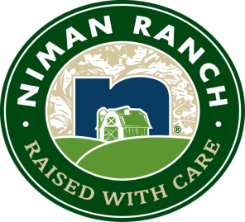

News Release
For Immediate Release
Media Contact:
Kerri McClimen: 773-746-7077
kerri.mcclimen@nimanranch.com

Niman Ranch proudly partners with Purely Meat Company
in Chicago and Indianapolis markets

Sustainable agriculture leader will be working with the distributor for Hyatt Hotels and
Gibsons Steakhouse to bring Certified Humane meats to more restaurants in the Midwest

NORTHGLENN, Colo. (May 11, 2017) — Niman Ranch rolled out the distribution of its Certified Humane® meats with Chicago-land purveyor Purely Meat Co. Purely Meat will be supplying Niman Ranch’s beef, pork, lamb and prepared products to restaurants throughout the Chicago and Indianapolis markets.

“The folks at Purely Meat share a commitment to quality products and building integrity-based relationships that makes them a natural fit with our family farmers and ranchers who produce our great tasting meat,” says Niman Ranch General Manager Jeff Tripician. Niman Ranch meat is third-party-certified under the Certified Humane® program and raised by a community of more than 720 small, independent U.S. family farmers who adhere to some of the strictest animal welfare protocols in the industry. All products are sustainably raised without the use of antibiotics or hormones.

Purely Meat Co. is a Chicago based meat purveyor with a rich family history of high quality meats and old-world butchery. “Here at Purely, I have built a business searching out partners that share our passion for family, farming and food,” says Maribel Moreno-Musillami, owner of Purely Meat. “We continue to search long and hard and are proud to join into a partnership with Niman Ranch. Niman exemplifies these values in every pound of meat produced.”

Most notably in Chicago, Purely Meat will be processing and delivering Niman Ranch’s Midwest-raised pork to the world-famous Gibsons Bar & Steakhouse. Gibsons has received several recognitions as one of America’s best steakhouses since opening in 1989. The Niman Ranch pork chop is branded on the menu at all Gibsons locations.

Nationally, Purely Meat will be working with Hyatt Hotels, known as one of the world’s top hospitality companies, to provide a full line of Niman Ranch to Chicago-area hotels.

###

With more than 40 years as an industry leader, Niman Ranch is a community of more than 720 independent family farmers and ranchers who raise livestock traditionally, humanely and sustainably to deliver the finest-tasting meat. All Niman Ranch pork, beef, lamb and prepared products are certified under the Certified Humane® program and available nationwide at both food service and retail locations.

